**Appointment Notifications**

1. A registered patient logs in to the application and books an appointment.

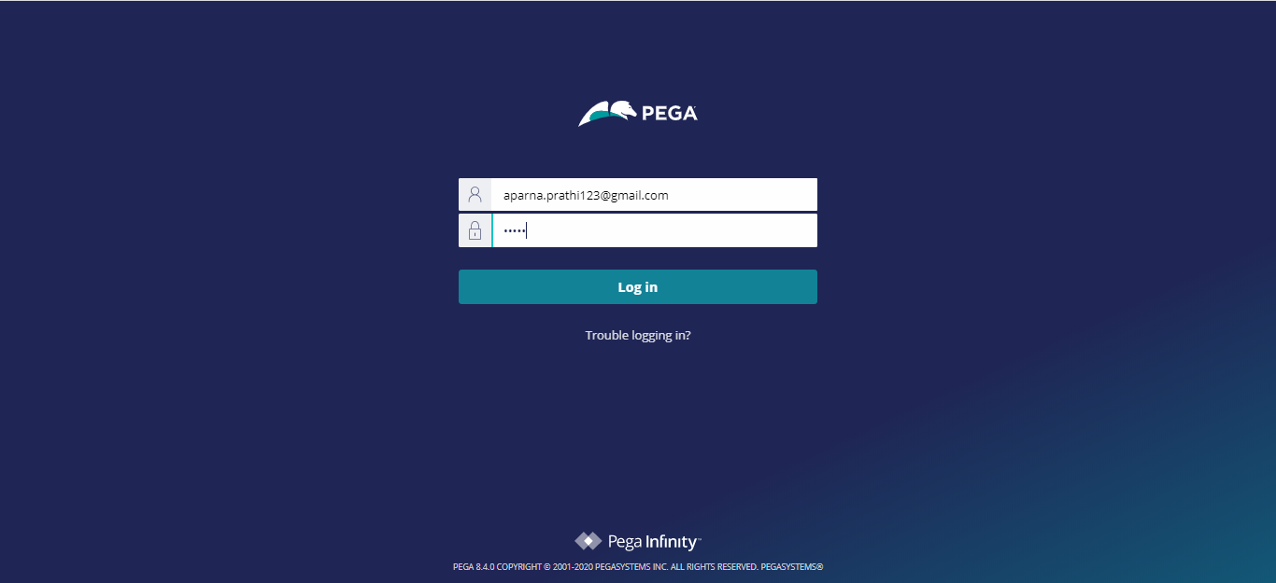

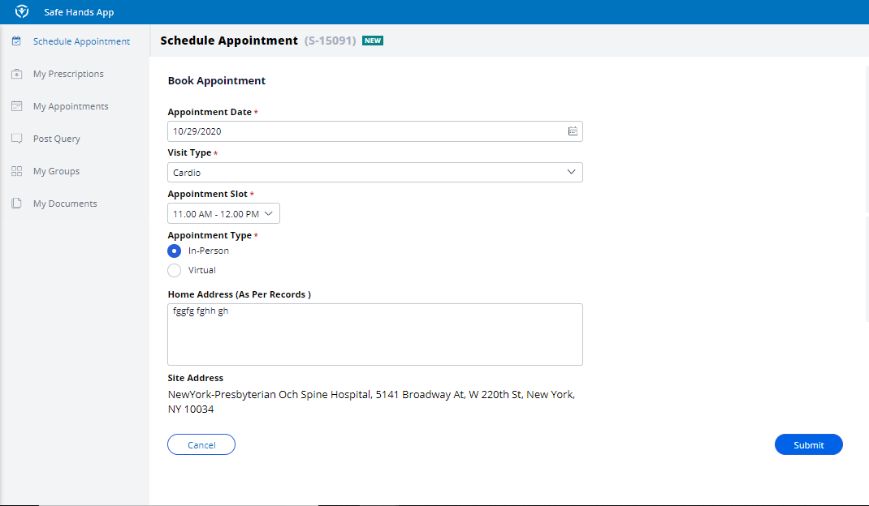

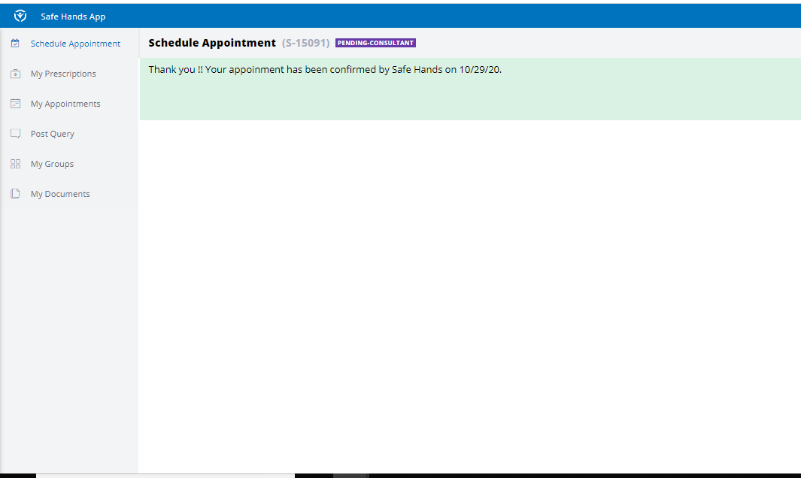

1. Patient receives a reminder notification one day before the date of consultation to remind him of the upcoming consultation.

